Quick, Weekend Wood Projects
Unique Idea For Every Holiday

By Jim Shutes

Saturday, October 2, 2004

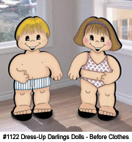
Now here’s a fun and unique idea that can be used for every holiday: Dress-Up Darlings! This adorable pair can stand in the corner of your house, or out on your lawn, promoting just about anything. You change their clothes for any season, holiday, sporting event, or just about anything.
Here is how it works. You cut the boy and girl out of your plywood, and paint them. They are wearing just their underwear. You then cut out and paint their holiday or event clothes and Velcro them to the kids. As the holiday changes, or you want to display a different event, simply cut out a different design, paint it, and Velcro it to the kids. By doing this, you reduce the amount of wood, paint, and time spent having to do the entire display. Plus, it’s a lot of fun changing their outfits every once in a while!
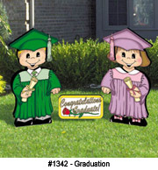
Dress-Up Darlings are great for special events, such as reunions, parties, graduations, open houses, sporting events, get-togethers, and more! The outfits can contain the different objects that the event would call for. For example, if it was a hockey event, the kids could be wearing a hockey uniform, complete with helmets, skates, hockey sticks, face masks, etc. For a graduation, they would obviously wear cap and gowns in your graduate’s school colors. The applications are endless! For added touches, fill theme or event balloons with helium and attach them to the kids’ hands.
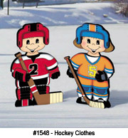
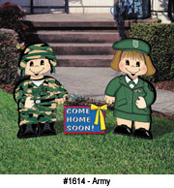
To create your dolls, find a good pattern or design of a boy and girl cartoon character. If you draw well, you can do this yourself. If not, don't fret, there are companies out there that sell patterns, such as these. Trace them onto ½” plywood and cut them out. Paint the boy and girl a skin color over the entire body. Once dry, use a pencil to draw the features, such as hair, eyes, nose, mouth, etc. before going over it with paint or paint pens (make sure it looks good before making it permanent). Use a thin brush to paint over the pencil. Or, to make it much easier, use a paint pen. This will give you much more control. If you wish, you can paint underwear on them, but they will never be seen. So it is up to you. Their hair will be seen, so you will need to paint that. To finish the dolls, just add some feet, so they will stand on their own. Cut out rectangular-shaped feet, and round them at one end (so that they look like an oval at one end and a rectangle at the other). Make them the same width as the feet of the doll, or just wider than the legs. Paint them black. Nail or screw the feet up through the middle of the flat feet and into the bottom of the vertical legs or feet.
Now that you have the dolls done, you just need some clothes. Using the shapes of the dolls as a guide, either sketch up some ideas for clothes (based on their sizes), or find some pattern ideas either on the web, or from Sherwood. The tracing, cutting and painting are done the same way as the dolls. Once they are dry, apply Velcro to the back of the clothes and to the dolls, and hang the clothes onto the dolls. You are done! Now, each season, or event, you can change the clothes to match. What a great way to decorate around the house, the yard or at a party!
If you would like detailed instructions and a full-size pattern for this project (Dress-Up Darlings Dolls #1122, but ask about different clothes designs, too), send a copy of this article and $7.95 (plus $3.95 S&H), check or money order, to Dept. 101, Sherwood Creations, Inc., 1459 N. Leroy St., Fenton, MI 48430. If you would like to pay by credit card, please call toll-free (800) 843-2571 or go to www.SherwoodOnline.com.
A Flowering Beauty In Minutes!

A Beautiful Flowering Planter In Minutes!

Create Something Special With Simple Tools!

Create Something Extraordinary With Ordinary Tools!

Give Your Home A New Look

Quick Cash From Scrap Wood

Fresh New Ideas For The Weekend

Beautiful New Ideas For The Weekend

