Quick, Weekend Wood Projects
Simple, Elegant Plant Stand
From Landscape Timbers

By Jim Shutes

Saturday, September 4, 2004

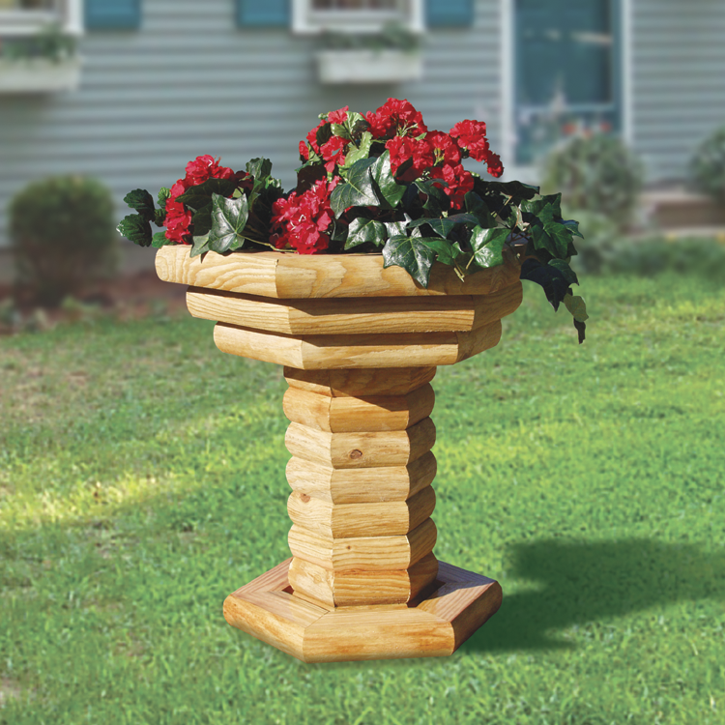
Now here’s a way to add a flowering touch to your yard or garden without a lot of effort: build a plant stand from ordinary landscape timbers. Anyone can build this simple design, and all it takes is some wood and screws. A beautiful landscape timber plant stand could be all that your yard is looking for, and you can do it this weekend, in just a few hours!
Shaped like a birdbath, this clever design brings your flowers up, off the ground, while allowing you to place the plant stand just about anywhere in your yard or garden. Having multi-tiered flower beds can give your flower garden a very unique and rewarding look.
If you have never worked with landscape timbers before, you are in for a treat. You can create wonderful things with them, and you can pick them up at any lumber yard or Home Depot, etc. They are strong, sturdy, and are treated, so that they last for many years without rotting. Their rustic appearance gives an extra added ruggedness to your outdoor atmosphere, especially if you don’t paint your project, and leave it natural. I, myself, love the look of natural wood. When I look at natural landscape timbers, I get more of a rustic, backwoods, log cabin feeling. To me, you can never have too many landscape timber displays in your yard or garden. Try it. You will never look back!
CUTTING NOTE: If after making your 30-degree angle cuts on your hexagons, you find that the angles don’t quite line up, you can make some adjustments to fix this. If, when you assemble your hexagon, your gap increases as it goes to the inside of the hexagon, then you need to INCREASE the angle on your saw by a degree or two. If, on the other hand, your gap increases as it goes to the outside of the hexagon, then you need to DECREASE the angle on your saw by a degree or two.
If you would like detailed instructions and a full-size pattern for this project (Landscape Timber Plant Stand #1825), send a copy of this article and $8.95 (plus $3.95 S&H), check or money order, to Dept. 101, Sherwood Creations, Inc., 1459 N. Leroy St., Fenton, MI 48430. If you would like to pay by credit card, please call toll-free (800) 843-2571 or go to www.SherwoodOnline.com.
A Flowering Beauty In Minutes!

A Beautiful Flowering Planter In Minutes!

Create Something Special With Simple Tools!

Create Something Extraordinary With Ordinary Tools!

Give Your Home A New Look

Quick Cash From Scrap Wood

Fresh New Ideas For The Weekend

Beautiful New Ideas For The Weekend

