Quick, Weekend Wood Projects
Build Your Own Planter From Scraps

By Jim Shutes

Saturday, August 21, 2004

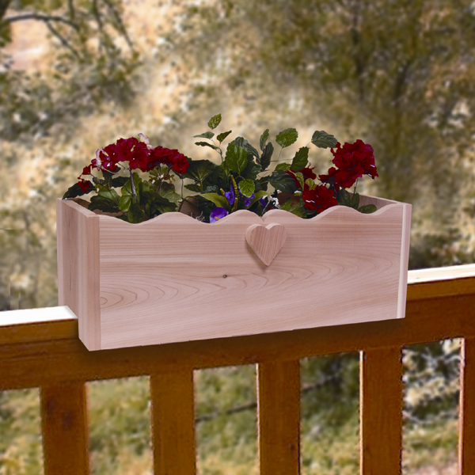
Are you looking for a way to spruce up your dull deck or drab house windows? One way to beautify these areas is with a gorgeous, flowering planter box. Planters come in all shapes and sizes, and are a wonderful accent to your yard, garden, and even inside your house. And best of all, they are really easy to build. With only a few scraps of wood, and a few hours, you can create a beautiful planter this weekend!
If you are looking for a really quick and simple planter to build, one that will take you only minutes to build, then the Window Sill or Railing Planter is the one for you! In about a half hour, you can have this planter in place, and sporting your favorite flowers.
Cut 2 pieces of wood for the front and back, 24” x 9½” from ¾” lumber. Cut a nice, wavy design across the top length of one of the pieces. Cut 2 pieces of wood 9½” x 9½” for the ends, also from ¾” lumber. Cut a notch, at the bottom of both of these 9½” square pieces, that measures 5½” wide, by 1½” tall, to fit a standard 2” x 6” deck rail. You should verify the width of your deck rail before cutting the notches. And finally, cut your last piece of ¾” lumber to measure 7¾” x 24”, for the floor.
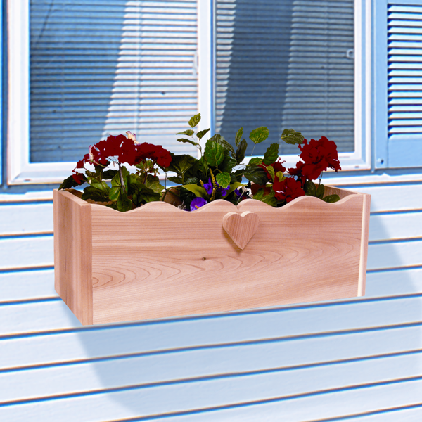
Now that you have all of your pieces cut, you are ready to assemble your new planter. Using waterproof wood glue and nails, attach the 9½” x 9½” end pieces to the 24” x 9½” front/back pieces, by nailing through the 9½” x 9½” pieces and into the ends of the 24” x 9½” pieces. Make sure that the notches on the end pieces are at the bottom. Next, drop in the 7¾” x 24” floor piece so that it is horizontal and sits just above the notches. Nail in from the end pieces and into the floor. Now your planter is built!
If you plan to use this planter as a deck railing planter, set the planter onto the railing. If you are concerned about the planter falling off the railing, then nail or screw down through the floor and into the railing, for stability. You can also drill 1/4” drain holes on the back side of planter, so water drips to the ground, away from the surface of your deck.
If you plan to use this planter as a window sill planter, using 3” deck screws, position the planter a few inches below a window sill on the outside of your house (centered left and right) and screw through the back of the planter and into the outside wall of your house. For safety reasons, check for any possible wiring that might be behind the wall.
Once you have your gorgeous, new planter in place, plant your favorite plants or flowers. It will brighten up your yard or window, and put smiles on the faces of all who pass by!

This planter will fit 3 - 8” flower pots, or a standard 24” plastic flower tray.
If you would like detailed instructions and a full-size pattern for this project (Rail Planter #1827), send a copy of this article and $6.95 (plus $3.95 S&H), check or money order, to Dept. 101, Sherwood Creations, Inc., 1459 N. Leroy St., Fenton, MI 48430. If you would like to pay by credit card, please call toll-free (800) 843-2571 or go to www.SherwoodOnline.com.
A Flowering Beauty In Minutes!

A Beautiful Flowering Planter In Minutes!

Create Something Special With Simple Tools!

Create Something Extraordinary With Ordinary Tools!

Give Your Home A New Look

Quick Cash From Scrap Wood

Fresh New Ideas For The Weekend

Beautiful New Ideas For The Weekend

