Quick, Weekend Wood Projects
Build Your Own Adirondack Set

By Jim Shutes

Saturday, January 22, 2005

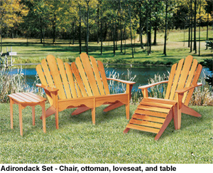
Have you ever thought about building your own deck or lawn furniture? It’s easy to do and very rewarding! One of the most popular deck furniture is an Adirondack chair. It’s very comfortable and fits to the contour of your body. The Adirondack chair is also very easy to make. It’s basically sides and slats. However, you must get the side contour right, or it won’t be comfortable. To do this, you may want to pickup a plan for a few dollars.
Even better than an Adirondack chair, is an Adirondack set. Build a matching set with chairs, loveseat, tables, and ottomans. Use an Adirondack set on your deck for sunning. Sit in comfort out on your lawn, patio or sunroom.
An Adirondack set will last for many years to come! If you use a good waterproof wood glue (such as TiteBond II) and treat your wood with a good polyurethane sealer (such as Hydrocote Polyshield), your Adirondack set will be able to withstand all types of weather, and be enjoyed for a long, long time.
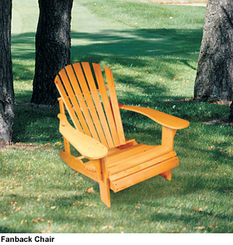
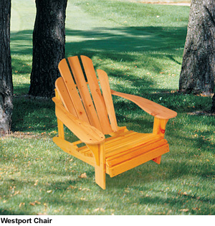
There are a few ways to accomplish building an Adirondack set. You can try to find a good design, and mimic it; or, you can buy a wood plan or pattern and guarantee that the shapes will be right; or, the easiest way is to buy a pre-cut kit and assemble it when it arrives. The first can be very aggravating, time-consuming and costly. The second is the most cost-effective, but you will need to put a little time into it. The third is by far the easiest and quickest way to build your own Adirondack set, and is much cheaper than buying ready-made outdoor furniture.
There are a few variations of deck furniture. These are basically minor differences in shape. There is the traditional Adirondack chair, the Fanback chair, and the Westport chair, to name a few. Notice in the pictures, shown here, that the basics of the chairs are similar, but the backs are slightly different. By combining these variations, they give you some wonderful contrasts on your deck for you and your friends to enjoy for many years!
If you would like detailed instructions and a full-size pattern for these projects, send a copy of this article and $20.95 for the Adirondack set #208-S (plus $5.25 S&H), or the Fanback Chair Pattern #1974 for $12.95 (plus $3.95 S&H), or the pre-cut Fanback Chair Kit #K-601 with everything you need to build it for $99.95 (plus $9.45 for S&H), or the Westport Chair #1979 for $12.95 (plus 3.95 S&H) check or money order, to Dept. 101, Sherwood Creations, Inc., 1459 N. Leroy St., Fenton, MI 48430. If you would like to pay by credit card, please call toll-free (800) 843-2571 or go to www.SherwoodOnline.com.

