Quick, Weekend Wood Projects
Bring Your Projects to Life with Plastic Eyes

By Jim Shutes

Saturday, March 19, 2005

Do you ever wish that you could make your animals and people more real-looking? Does it seem like the flat, painted eyes just need a little something extra to bring them to life? Plastic craft eyes will do the trick!
Plastic eyes are very inexpensive and come in all shapes and sizes. Some of them have a small insert on the backside that can be inserted into pre-drilled holes and glued into position. Others, such as glue-on eyes, moveable plastic eyes, and glass eyes, can just be glued onto any flat surface.
You won’t believe what a difference it makes to use these types of plastic craft eyes! Since the eyes are 3D, they give off reflections, similar to real eyes. They also come in many different sizes (from 15/64” diameter to around 1½”) and colors (including glow-in-the-dark, for the Halloween projects), such as black, brown, blue, yellow, amber, green, and so on, so you can REALLY give some contrast to your projects. This is important, since people tend to look directly into the eyes of people and animals. A lot of times, the eyes are the first thing that you focus on. And it can be a lot more exciting to look at reflective, colored, 3D eyes, than flat, painted eyes.
Here are some examples of what these plastic animal eyes, and glue-on eyes can do for your projects.
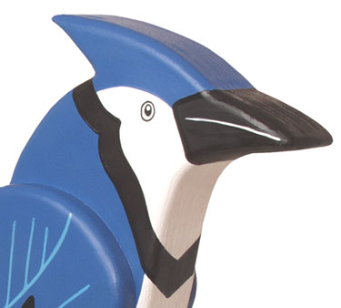

Before the Plastic Craft Eyes
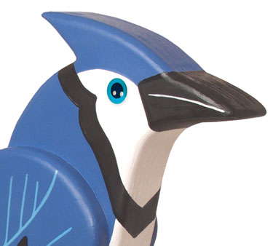

AFTER the Plastic Eyes!



Before the Plastic Craft Eyes



AFTER the Plastic Eyes!

Here is what a few different types of plastic craft eyes look like up close…
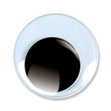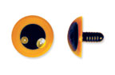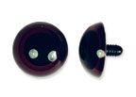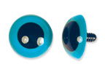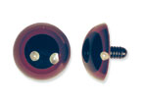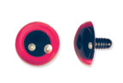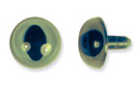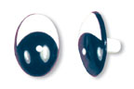

Plastic Craft Eyes are very inexpensive. When you buy them in packages of larger quantities, you can find them for as little as 16 to 25 cents a piece. When buying them one at a time, prices tend to be around 30 to 40 cents a piece. Either way, using plastic eyes on your dogs, cats, birds, people, snowmen, and teddy bears can be a very inexpensive way of bringing all of your projects to life!
If you would like to look through the plastic and moveable eyes offered by Sherwood Creations, please visit our website at www.SherwoodOnline.com, or click HERE to see a few pages of plastic eyes available. Sherwood Creations, Inc., 1459 N. Leroy St., Fenton, MI 48430. If you would like to order by phone, please call toll-free (800) 843-2571.

